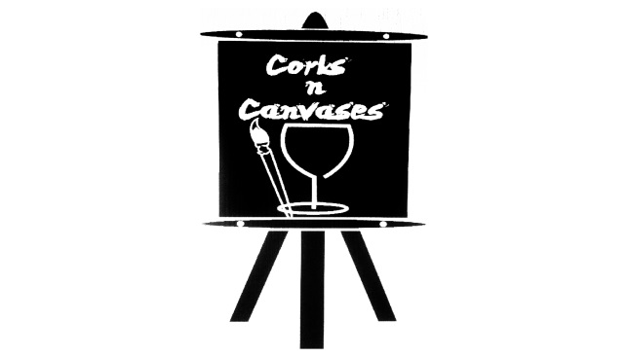
Private Party Info
Please review all of our private party guidelines, as we will need your signed and returned contract to hold your date.
Reservation Deposit: A refundable deposit of $70 (2 paint stations) is required to secure a private paint party. The deposit will be added to the total balance due.
Minimum requirements:
A minimum of 6 people for adult parties
A minimum of 10 for children parties
As the host of your party, it is your responsibility to make sure you that you have the minimum attending. We suggest that you collect payments in advance from your group or have them pay in advance online at www.corksncanvases.com or by calling us at 832/665-3336 to make payment by debit/credit card.
Time Allotments: Private parties can be booked for two-hour sessions at $35 per person or three-hour sessions at $45 per person for adult parties and $25 per person for children parties. We will allow a 15 minute grace period before and after to allow guests to arrive and get settled in and to make finishing touches to their painting.
Cancellation Policy: Although we hate not being able to paint with you, we do understand things happen that require you to cancel/reschedule. We require a 72 hour notice for cancellation of any private party. Deposits will be refunded ONLY if 72 hour notice is received via email at corksncanvases@gmail.com or by calling 832/665-3336. We will gladly reschedule your event if less than 72 hour notice is given.
Paint Party Supplies: 2 or 3 hours of painting time with instruction, canvases, aprons, easels, paints, brushes, water cups, and paint palettes.
* Corks N Canvases is not responsible for paint or damages to personal belongings, carpet, furniture, floors, clothing, etc. Acrylic paint can stain fabrics, please encourage your guests to dress accordingly.

